**DBMS PROJECT**

Music Library Database

GROUP MEMBERS

1. Harit Kumar Kharb

(RA1811030010037)

1. Jubin Raj Nirmal

(RA1811030010040)

1. Shreya Mahajan

(RA1811030010041)

# Abstract

Music Library Database Management System provides a simple interface for management and maintenance of Music Files and it’s meta data.

The use of Oracle SQLplus made it possible to consolidate the design of the system.

It can be used by any individual and is so designed to be used at ease without much complications and with a bombastic UX.

The updation and management of accurate and up-to date data regarding music files in a music application is very crucial. The system deals with all kind of information like album name, different genres, artists and all necessary data regarding the track being appended to the system.

The user is only needed to insert the music track file and rest is been taken cared by the system.

This DBMS provides a good amount of integrity and redundancy of files in the system so the security is intact within the reach of it.

The system is fully optimized and provides a good amount of benchmark with a great efficiency to render the music track files.

INTRODUCTION

The design and implementation of a comprehensive Music Library Management System and user interface is to replace the current paper records. User’s are able to directly access all aspects of a music track through a secure, offline interface embedded in the application. The system utilizes user authentication, displaying only information necessary for an individual’s duties. Additionally, each sub-system has authentication allowing authorized users to create or update information in that subsystem. All data is thoroughly reviewed and validated on the server before actual record alteration occurs. All data is stored securely on SQL servers and local storage managed by our staff and user respectively and ensures the highest possible level of security.

ER-DIAGRAM

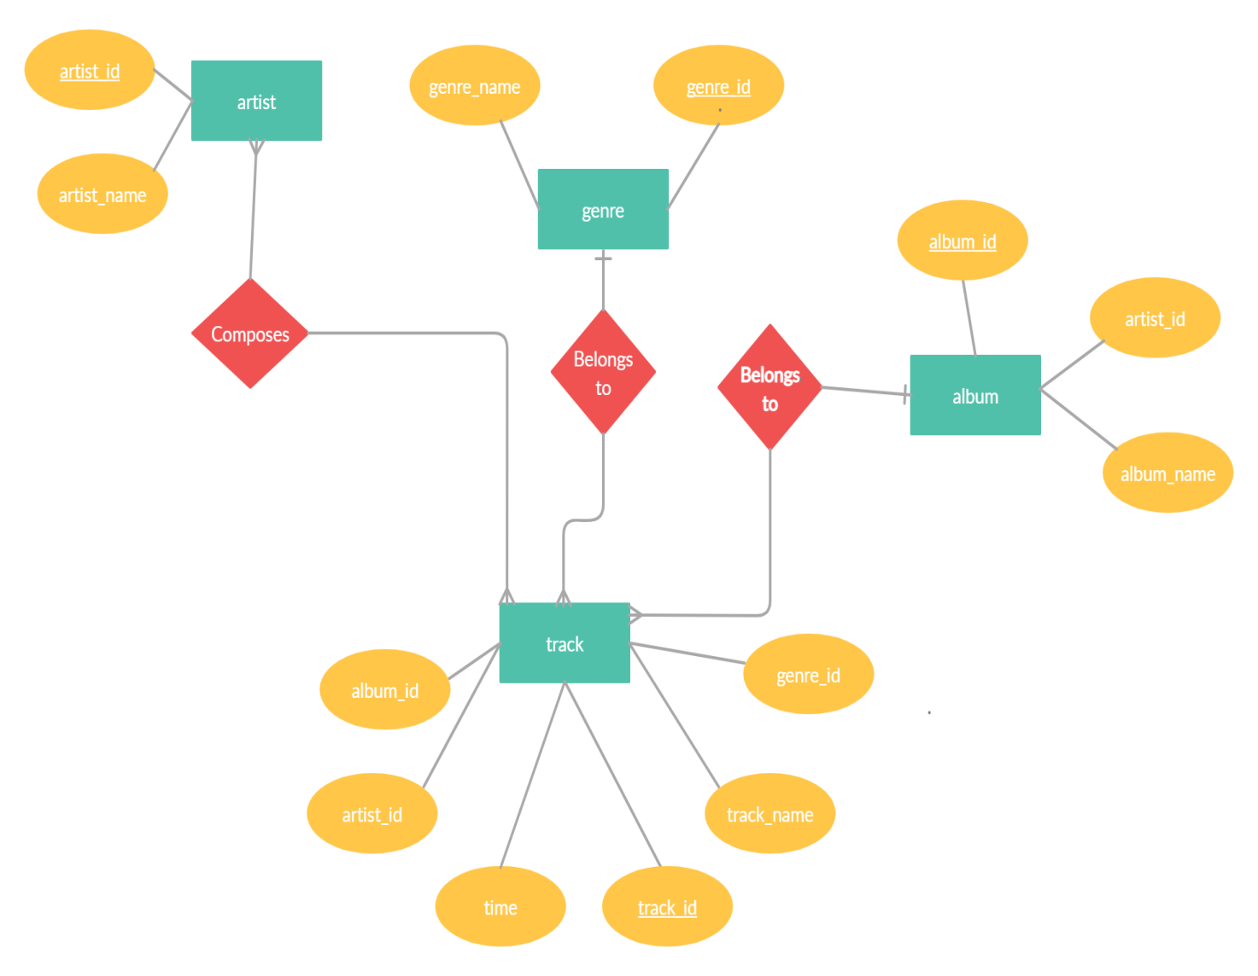

RELATIONAL SCHEMA

1. Artist

|  |  |  |  |
| --- | --- | --- | --- |
| **Column** | **Type** | **Null** | **Description** |
| artist_id *(Primary)* | int | No | Artist id (Primary key) |
| artist_name | char(128) | Default Null | Name of the artist |

1. Album

|  |  |  |  |
| --- | --- | --- | --- |
| **Column** | **Type** | **Null** | **Description** |
| album_id  *(Primary)* | int | No | Album id (Primary key) |
| album_name | char(128) | Default Null | Name of the  Album |
| artist_id | int | No | Artist id  (Foreign Key) |

1. Genre

|  |  |  |  |
| --- | --- | --- | --- |
| **Column** | **Type** | **Null** | **Description** |
| genre_id  *(Primary)* | int(200) | No | Genre id (Primary key) |
| genre_name | char(218) | Default Null | Name of the Genre |

1. Track

|  |  |  |  |
| --- | --- | --- | --- |
| **Column** | **Type** | **Null** | **Description** |
| track_id | int | No | Track id  (Primary Key) |
| track_name | char(128) | Default Null | Name of the song |
| artist_id | int | No | Artist Id  (Foreign Key) |
| album_id | int | No | Album id  (Foreign Key) |
| genre_id | int | No | Genre id  (Foreign Key) |
| time | Decimal(5,2) | Default Null | Time of the track |

Data Definition Language

Artist

CREATE TABLE artist

(

artist_id INT NOT NULL,

artist_name CHAR(128) DEFAULT NULL,

PRIMARY KEY (artist_id)

);

Genre

CREATE TABLE genre

(

genre_id INT NOT NULL,

genre_name CHAR(128) DEFAULT NULL,

PRIMARY KEY (genre_id)

);

Album

CREATE TABLE album

(

artist_id INT NOT NULL,

album_id INT NOT NULL,

album_name CHAR(128) DEFAULT NULL,

PRIMARY KEY (artist_id,album_id),

FOREIGN KEY (artist_id) REFERENCES artist(artist_id)

);

Track

CREATE TABLE track

(

track_id INT NOT NULL,

track_name CHAR(128) DEFAULT NULL,

artist_id INT NOT NULL,

album_id INT NOT NULL,

genre_id INT NOT NULL,

time DECIMAL(5,2) DEFAULT NULL,

PRIMARY KEY (artist_id,album_id,track_id,genre_id),

FOREIGN KEY (artist_id) REFERENCES artist(artist_id),

FOREIGN KEY (artist_id,album_id) REFERENCES album(artist_id,album_id),

FOREIGN KEY (genre_id) REFERENCES genre(genre_id)

);

Data Manipulation Language

Insert:

1. Artist

INSERT INTO artist VALUES (1, 'New Order');

INSERT INTO artist VALUES ('2', 'Nick Cave & The Bad Seeds');

INSERT INTO artist VALUES ('3', 'Miles Davis');

INSERT INTO artist VALUES ('4', 'The Rolling Stones');

INSERT INTO artist VALUES ('5', 'The Stone Roses');

INSERT INTO artist VALUES ('6', 'Kylie Minogue');

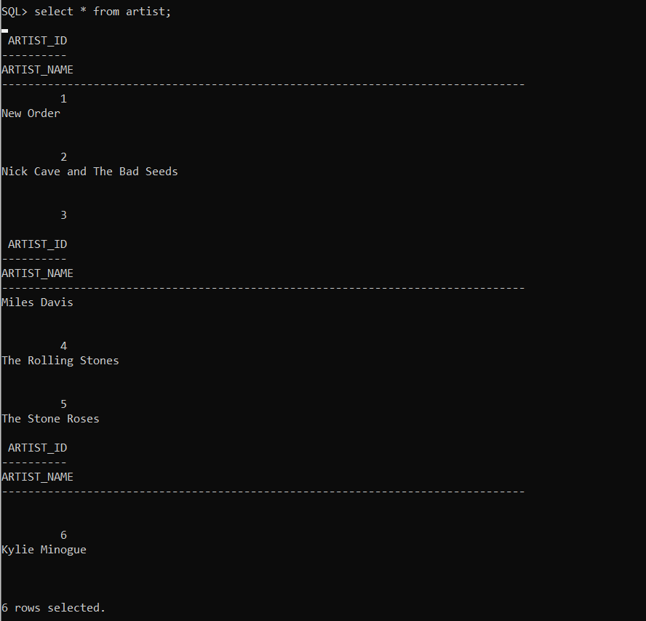

1. Genre

INSERT INTO genre VALUES ('1', 'pop');

INSERT INTO genre VALUES ('2', 'edm');

INSERT INTO genre VALUES ('3', 'rock');

INSERT INTO genre VALUES ('4', 'metal');

INSERT INTO genre VALUES ('5', 'synthPop');

INSERT INTO genre VALUES ('6', 'jazz');

INSERT INTO genre VALUES ('7', 'coolJazz');

INSERT INTO genre VALUES ('8', 'punk');

INSERT INTO genre VALUES ('9', 'classicRock');

INSERT INTO genre VALUES ('10', 'britPop');

INSERT INTO genre VALUES ('11', 'electroPop');

1. Album

INSERT INTO album VALUES ('2', '1', 'Let Love In');

INSERT INTO album VALUES ('1', '1', 'Retro John McCready FAN');

INSERT INTO album VALUES ('1', '2', 'Substance Disc 2');

INSERT INTO album VALUES ('1', '3', 'Retro Miranda Sawyer POP');

INSERT INTO album VALUES ('1', '4', 'Retro New Order Bobby Gillespie LIVE');

INSERT INTO album VALUES ('3', '1', 'Live Around The World');

INSERT INTO album VALUES ('3', '2', 'In A Silent Way');

INSERT INTO album VALUES ('1', '5', 'Power Corruption and Lies');

INSERT INTO album VALUES ('4', '1', 'xile On Main Street');

INSERT INTO album VALUES ('1', '6', 'Substance 1987 Disc 1');

INSERT INTO album VALUES ('5', '1', 'Second Coming');

INSERT INTO album VALUES ('6', '1', 'Light Years');

INSERT INTO album VALUES ('1', '7', 'Brotherhood');

1. Track

INSERT INTO track VALUES ('0','Do You Love Me','2','1','1','5.95');

INSERT INTO track VALUES ('1','Nobodys Baby Now','2','1','2','3.87');

INSERT INTO track VALUES ('2','Loverman','2','1','3','6.37');

INSERT INTO track VALUES ('0','Elegia','1','1','1','4.93');

INSERT INTO track VALUES ('1','In A Lonely Place','1','1','3','6.26');

INSERT INTO track VALUES ('2','Procession','1','1','4','4.47');

INSERT INTO track VALUES ('0','In A Lonely Place','1','2','3','6.30');

INSERT INTO track VALUES ('1','Procession','1','2','4','4.46');

INSERT INTO track VALUES ('2','Mesh','1','2','1','3.44');

INSERT INTO track VALUES ('0','Fine Time','1','3','3','4.71');

INSERT INTO track VALUES ('1','Temptation','1','3','2','8.71');

INSERT INTO track VALUES ('2','True Faith','1','3','3','5.88');

INSERT INTO track VALUES ('0','Ceremony','1','4','3','4.82');

INSERT INTO track VALUES ('1','Procession','1','4','4','3.57');

INSERT INTO track VALUES ('2','Everythings Gone Green ','1',4,5,'5.25');

INSERT INTO track VALUES ('0','In A Silent Way','3','1','6','1.81');

INSERT INTO track VALUES ('1','Intruder','3','1','6','4.87');

INSERT INTO track VALUES ('2','New Blues','3','1','6','5.58');

INSERT INTO track VALUES ('0','Shhh/Peaceful','3','2','7','16.67');

INSERT INTO track VALUES ('1','In A Silent Way Its About That Time','3','2','7','16.67');

INSERT INTO track VALUES ('0','Age Of Consent','1','5','8','5.26');

INSERT INTO track VALUES ('1','We All Stand','1','5','3','5.24');

INSERT INTO track VALUES ('2','The Village','1','5','8','4.62');

INSERT INTO track VALUES ('0','Rocks Off','4','1','9','4.54');

INSERT INTO track VALUES ('1','Rip This Joint','4','1','9','2.38');

INSERT INTO track VALUES ('2','Shake Your Hips','4','1','9','3.00');

INSERT INTO track VALUES ('0','Ceremony','1','6','3','4.42');

INSERT INTO track VALUES ('1','Everythings Gone Green','1','6','5','5.51');

INSERT INTO track VALUES ('2','Temptation','1','6','2','6.99');

INSERT INTO track VALUES ('0','Breaking Into Heaven','5','1','10','11.37');

INSERT INTO track VALUES ('1','Driving South','5','1','10','5.17');

INSERT INTO track VALUES ('2','Ten Storey Love Song','5','1','10','4.50');

INSERT INTO track VALUES ('0','Spinning Around','6','1','11','3.46');

INSERT INTO track VALUES ('1','On A Night Like This','6','1','11','3.55');

INSERT INTO track VALUES ('2','So Now Goodbye','6','1','11','3.62');

INSERT INTO track VALUES ('0','State of the Nation','1','7','3','6.56');

INSERT INTO track VALUES ('1','Every Little Counts','1','7','1','4.48');

INSERT INTO track VALUES ('2','Angel Dust','1','7','8','3.73');

Select:

Select track_name,track_id from track where artist_id>=5

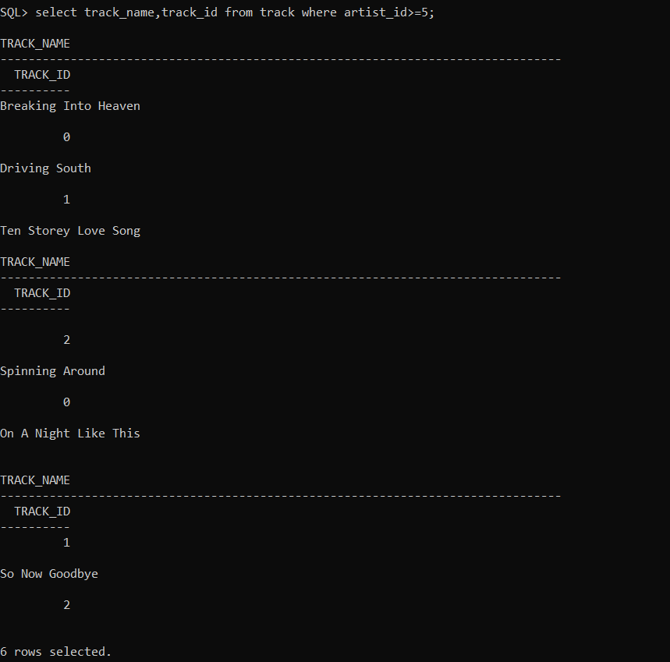

Select distinct genre_id from track;

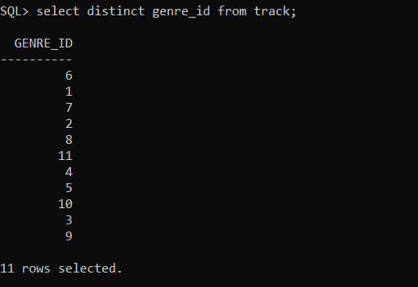

Select track_name,time from track where time in(‘3.00’,’4,50’);

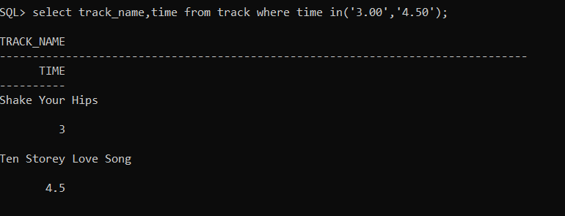

Select artist_id,artist_name from artist order by artist_id;

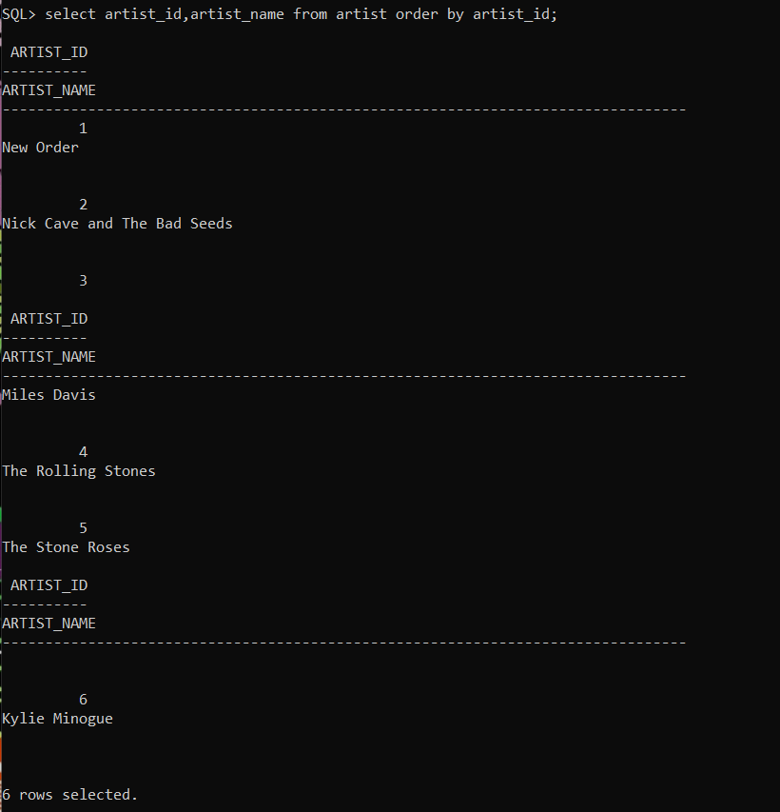

Select time,track_name from track where genre_id between 1 and 2 order by time desc;

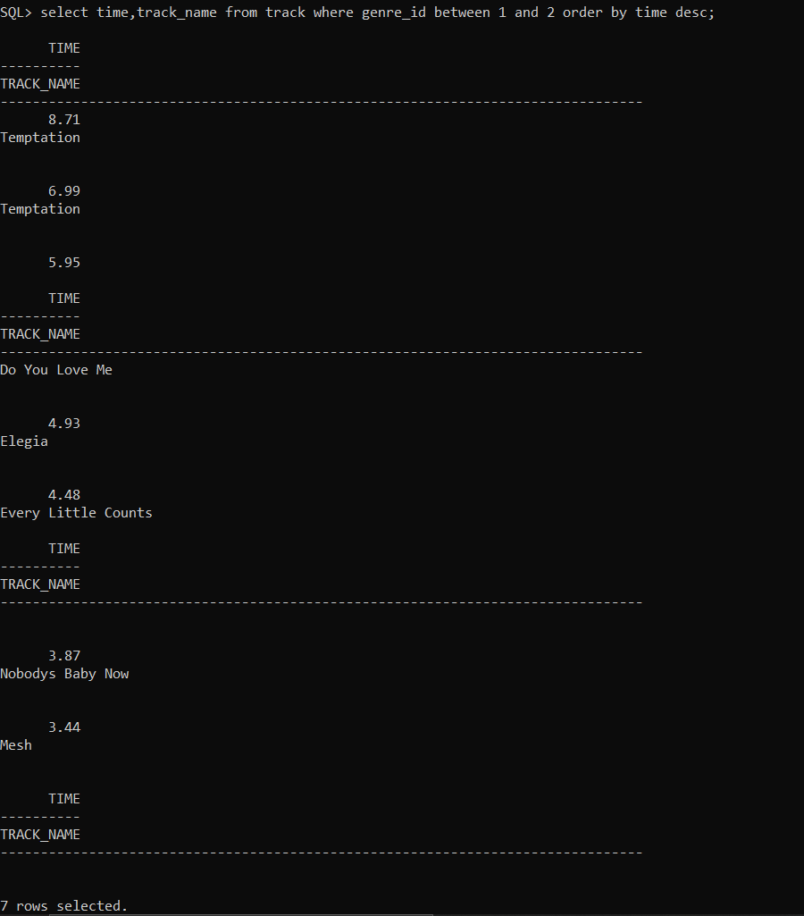

Select count(*),time from track group by time;

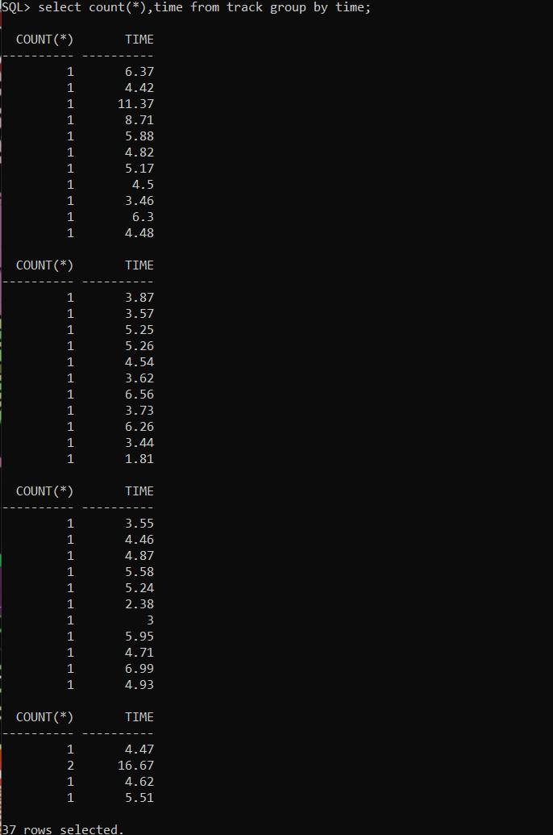

Set Operations

UNION

Select album_name from album union select artist_name from artist;

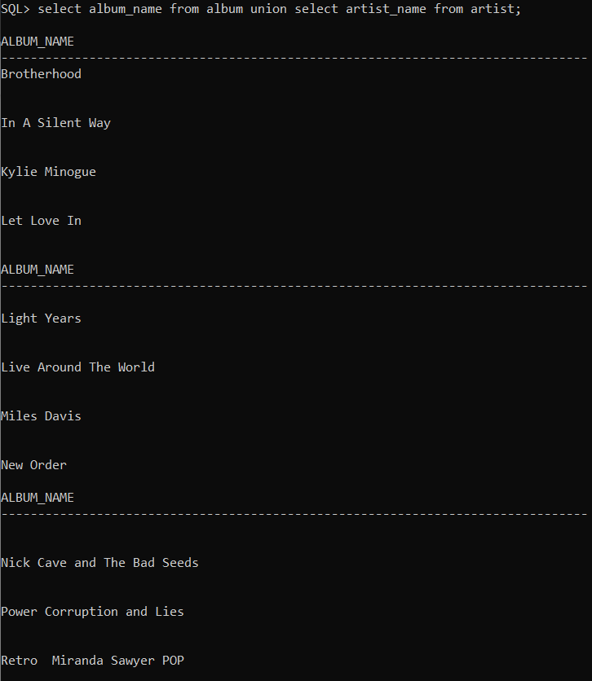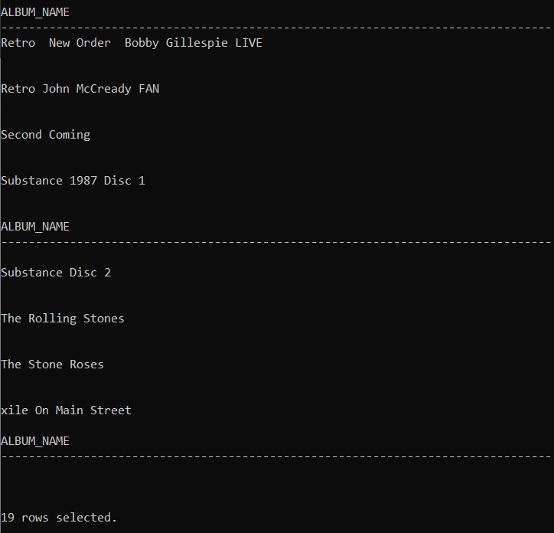

UNION ALL

Select track_name from track union all select album_name from album;

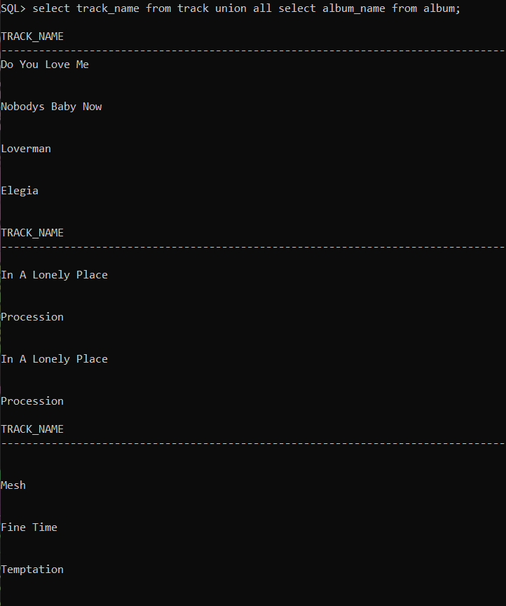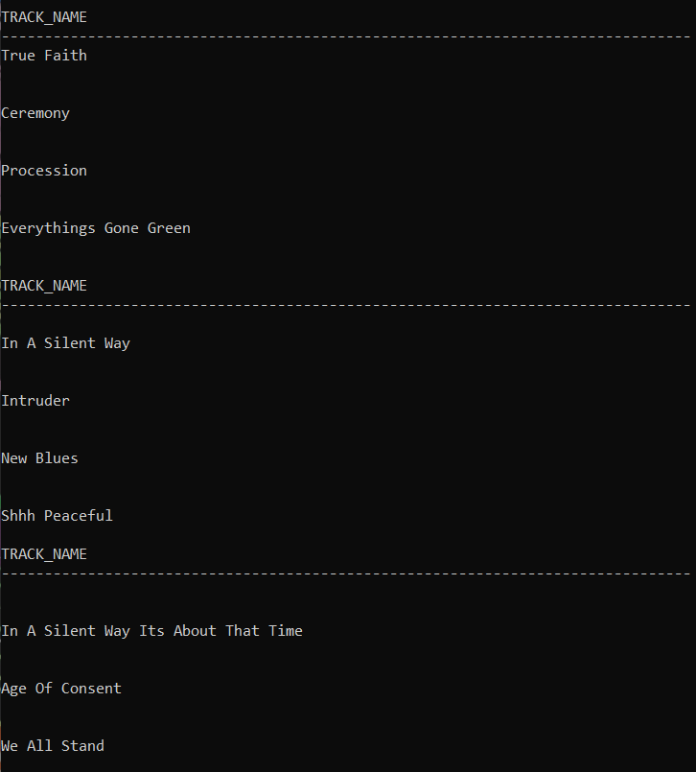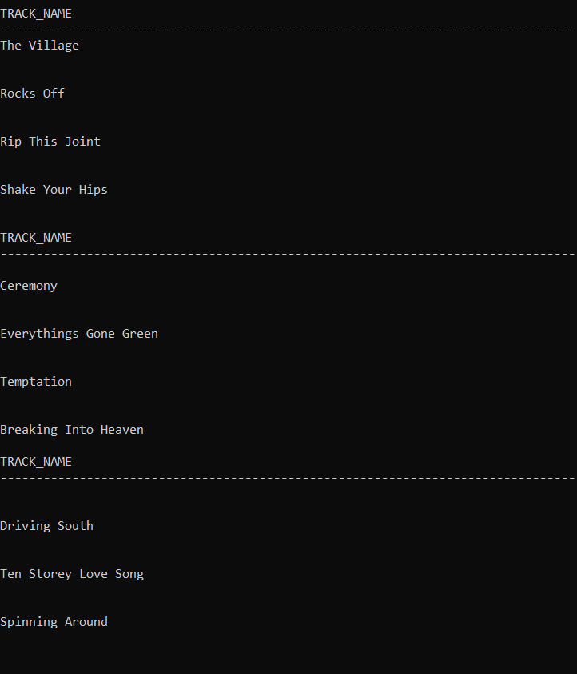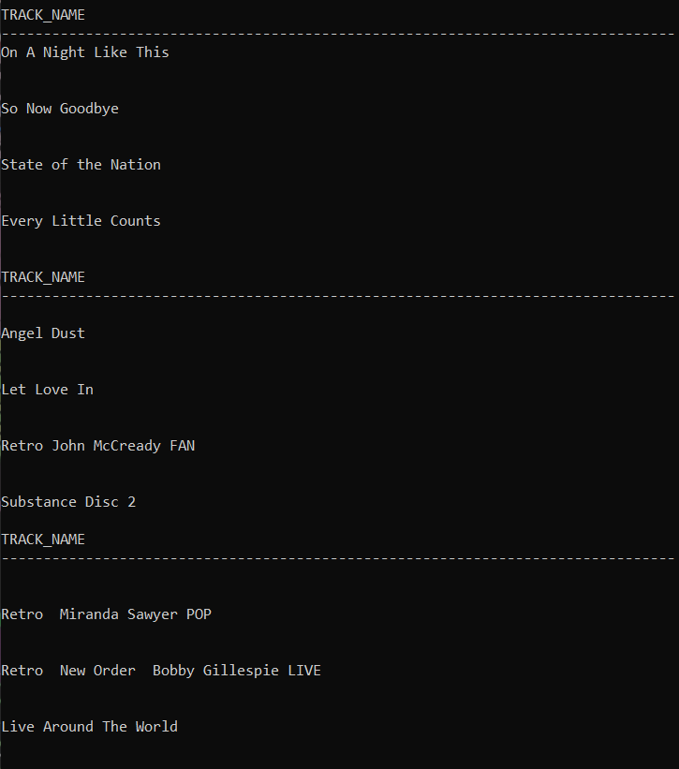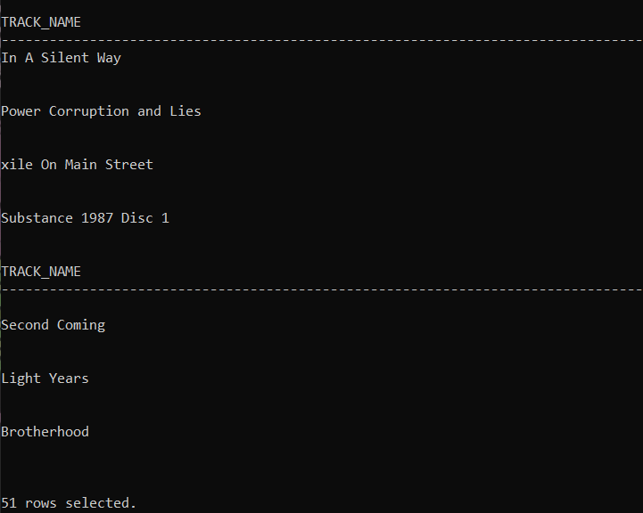

INTERSECTION

(select track_name from track) intersect (select album_name from album);

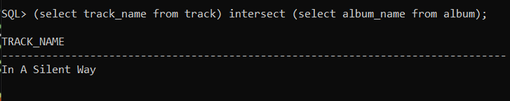

MINUS

Select artist_name from artist minus select album_name from album;

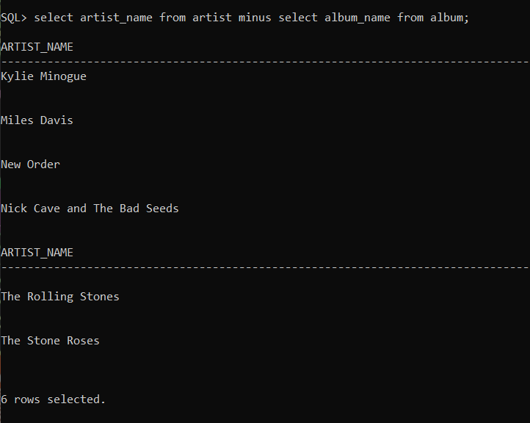

Aggregations

Select time, count(*) from track group by time;

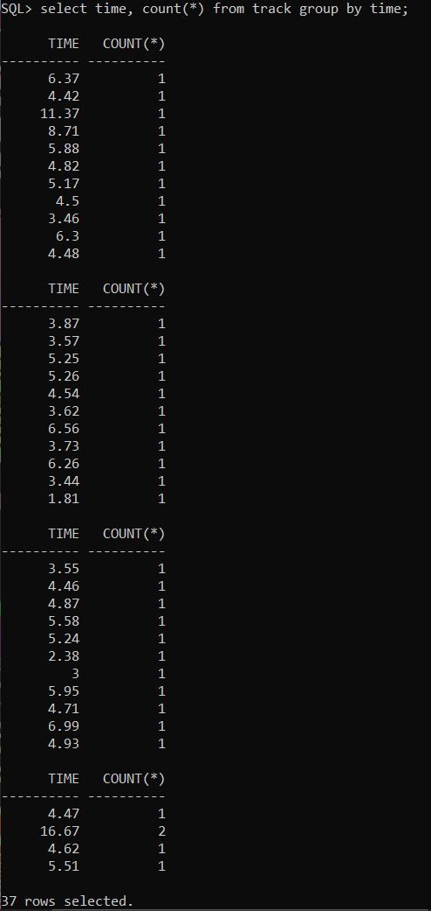

Select album_id, avg(time) from track group by order by album_id desc;

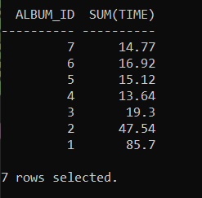

Select max(time) from track;

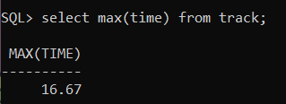

Select artist_id,avg(time) from track group by artist_id order by avg(time) desc;

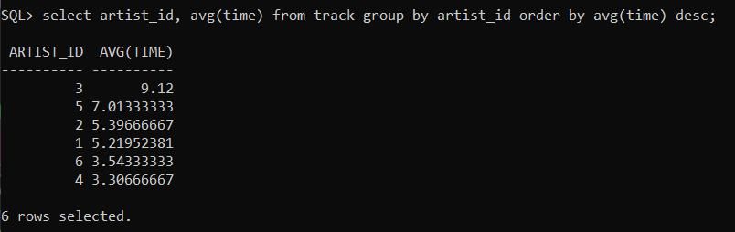

Select genre_id, count(*) from track group by genre_id;

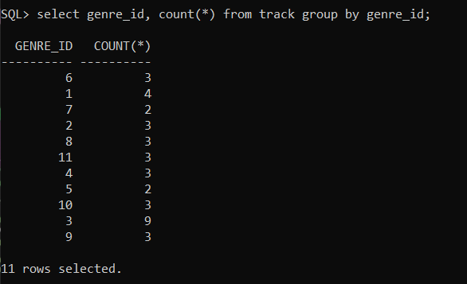

Select distinct(track_id) from track;

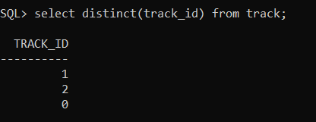

Select count(track_id) from track where time>5;

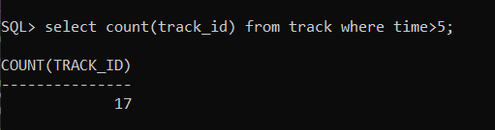

**JOINS**

* + - 1. INNER JOIN

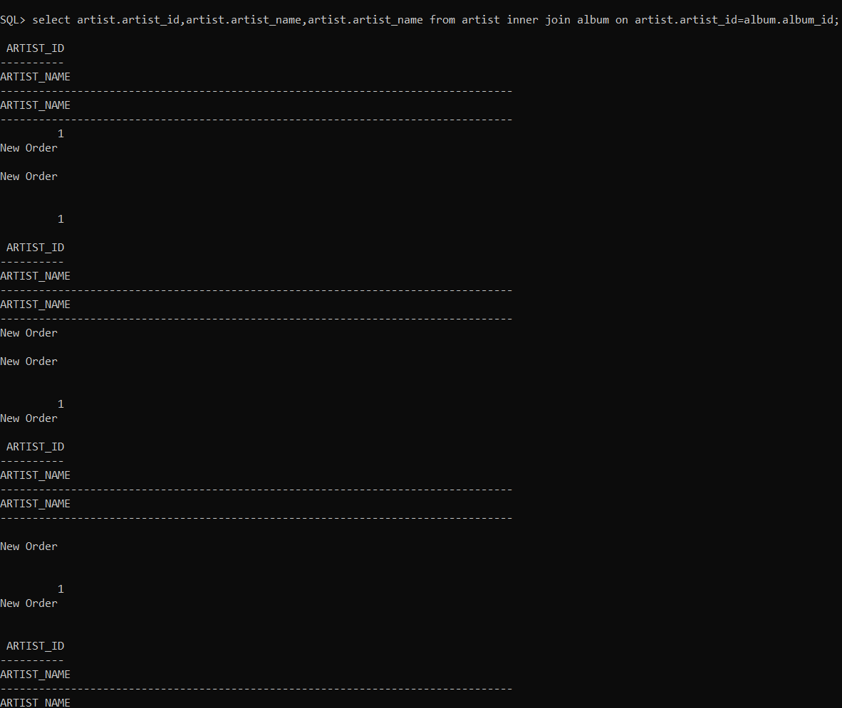

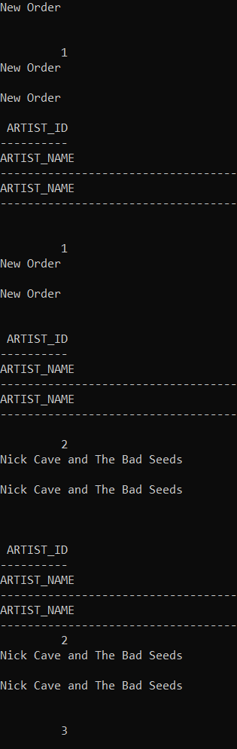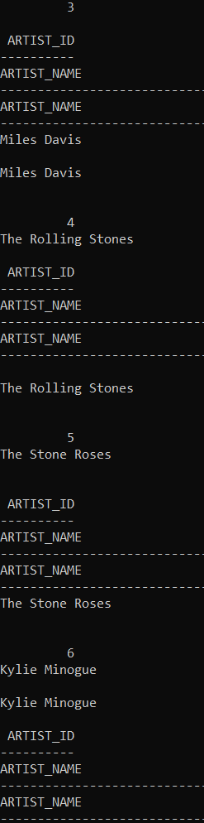

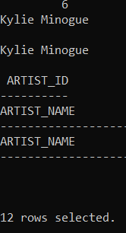

2.LEFT JOIN

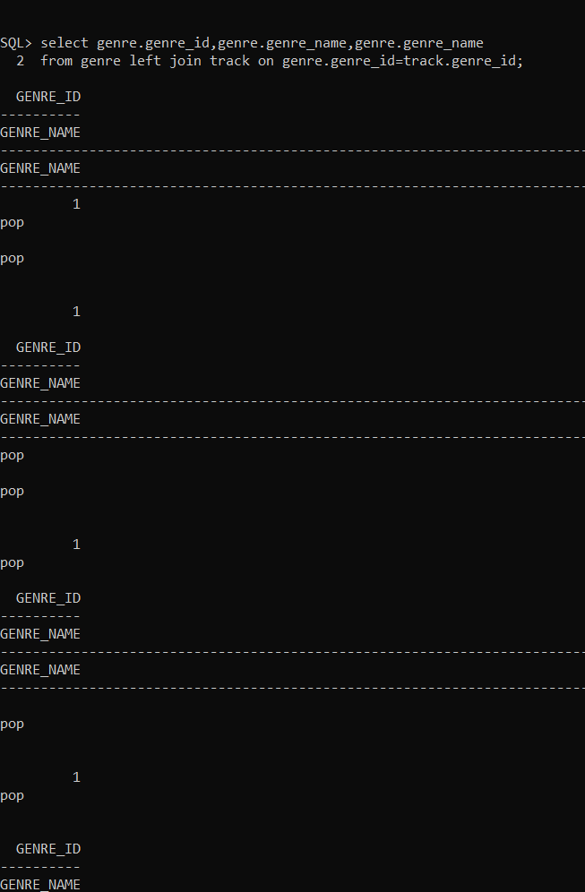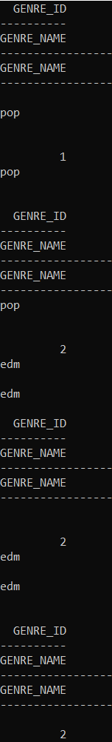

.

.

.

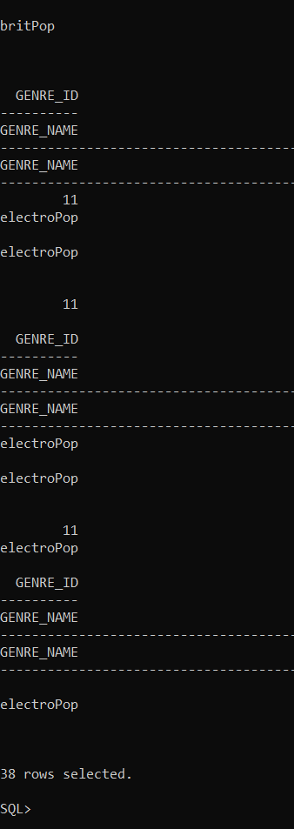

3.RIGHT JOIN

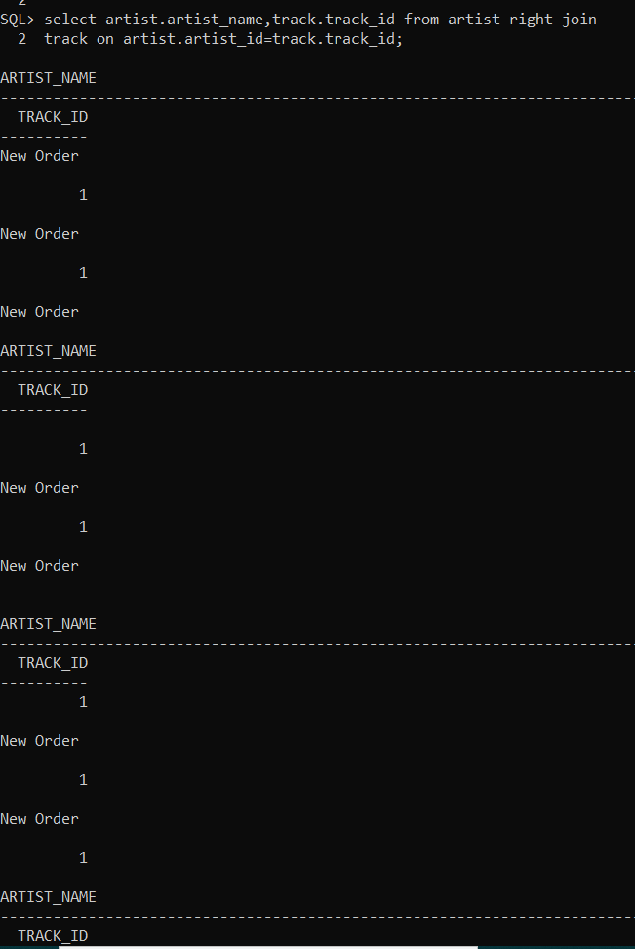

.

.

.

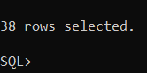

4.OUTER JOIN

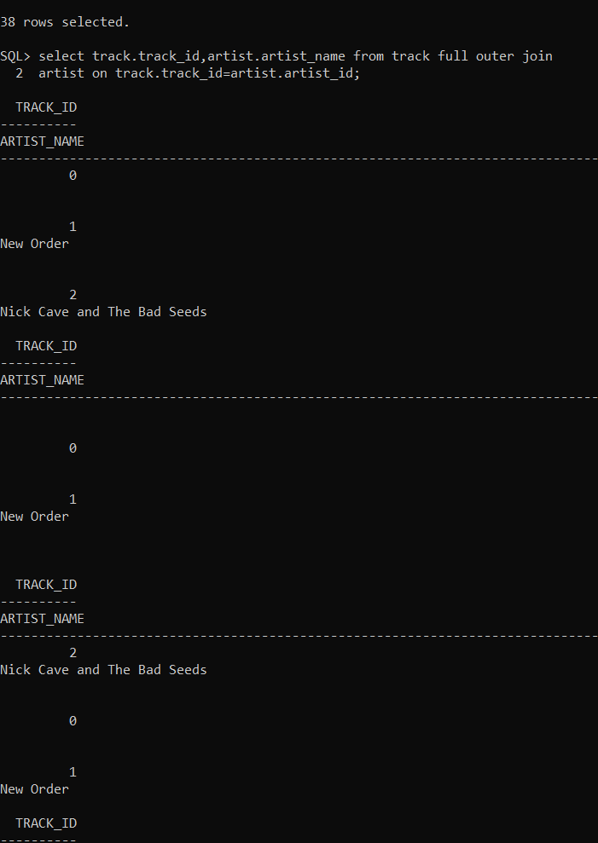

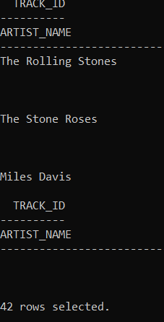

5.NATURAL JOIN

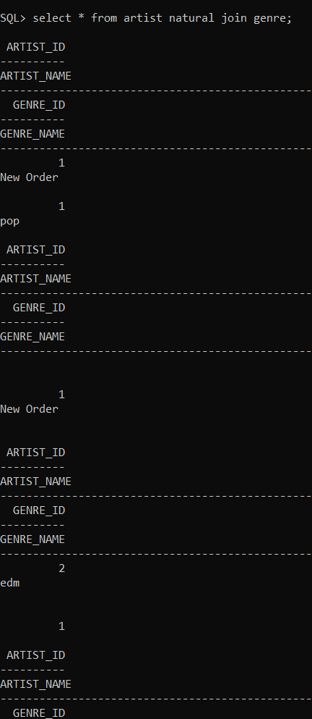

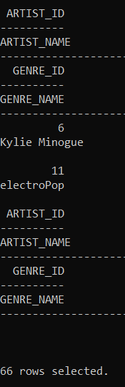

**SUB QUERIES** **Get the d**

**1.**

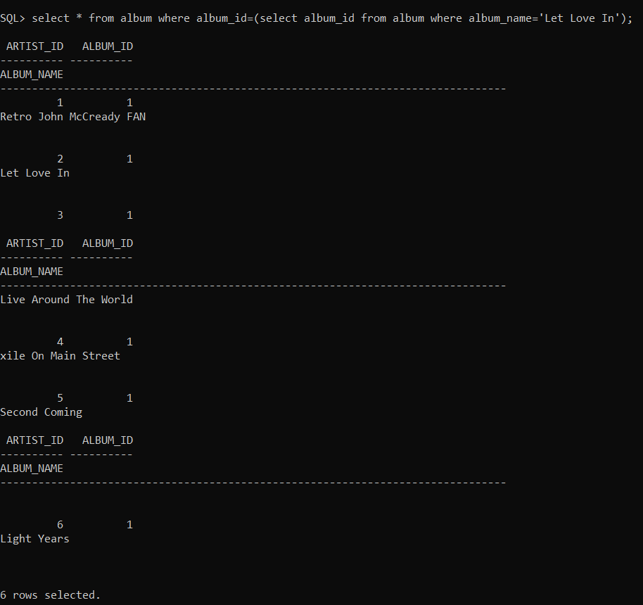

**2.**

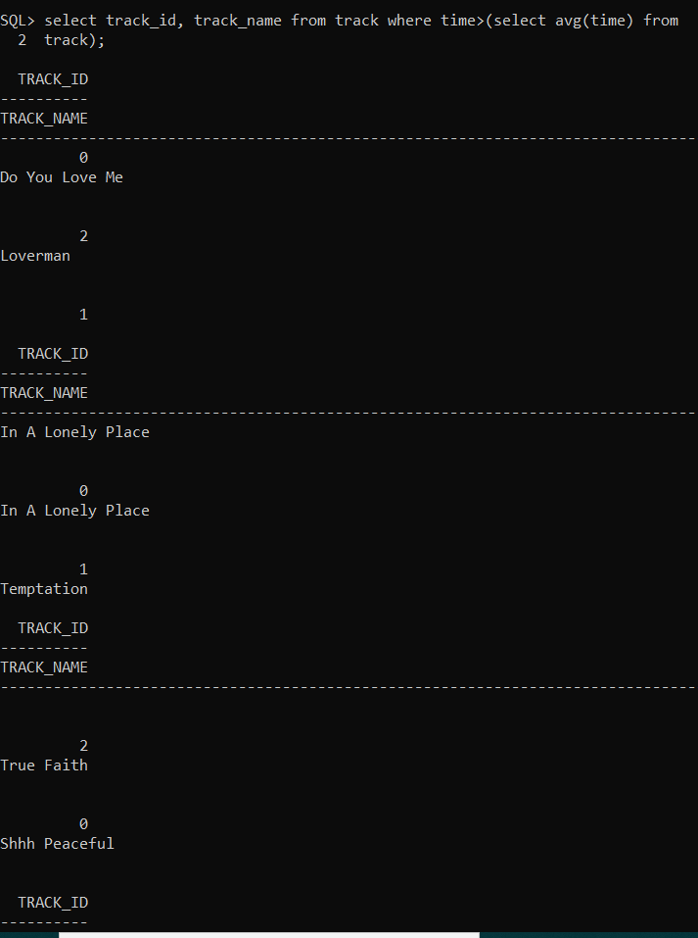

**.**

**.**

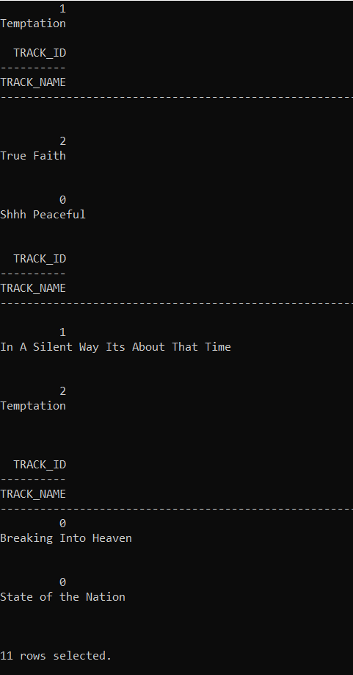

**3.**

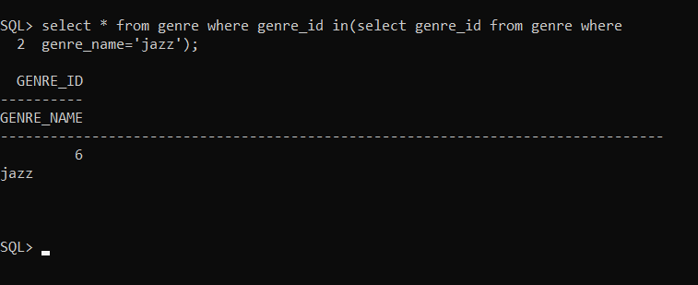

**4.**







